This section from: http://www.chockstone.org/TechTips/prusik.htm

The Prusik Knot
The good old prusik knot is very, very useful. All you need is a loop of cord which you can make using 6 or 7mm accessory cord and a double fisherman's knot. With one or two prusiks you can ascend a rope, or rig a z-pulley to haul up an injured climber, or backup an abseil (“abseil” is aka “rappel”). Suffice it to say it's worth learning this gem of a knot. There are numerous variations on the prusik such as the "autoblock", but follow these steps to tie the standard prusik knot:
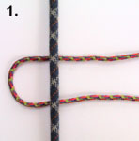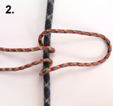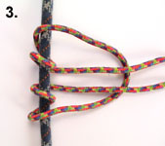
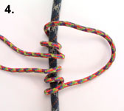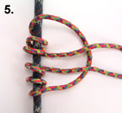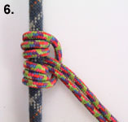
As you can see you simply wrap the loop of cord around the rope going through the inside of each previous wrap. The more wraps the "grippier" the knot. Three wraps is generally enough. Step 6: Pull the knot tight, neaten up the wraps and use the tail loop to clip into. Leaving the knot a little loose it can be slid up and down the rope. Weight the knot and it will grab the rope and lock off. Note: this form of prusik knot can sometimes be difficult to loosen once it has been tightened by the weight of a climber.

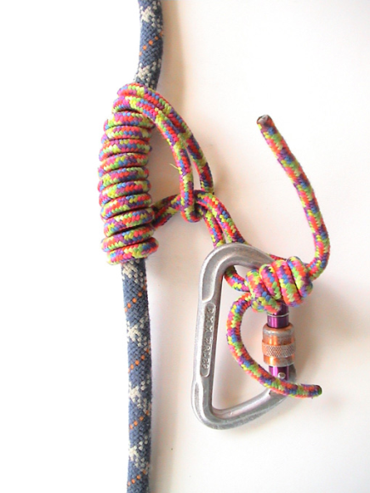
The "Klemheist" and "AutoBlock" Knot
The difference with the Klemheist (also called "Machard", or "French Prusik") compared to the normal Prusik is that it can be moved once weighted and will work with webbing as well as cord. This can be very handy in certain situations. Follow these steps to tie a Klemheist:
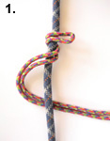Step 1: Simply wrap a loop of cord around the rope several times. Step 2: Feed the bottom tail through the top tail and clip bottom tail with your load.
The "Autoblock" is essentially the same knot as the Klemheist, except that in the last step you simply clip both tails together with a carabiner, rather than feeding one through the other.
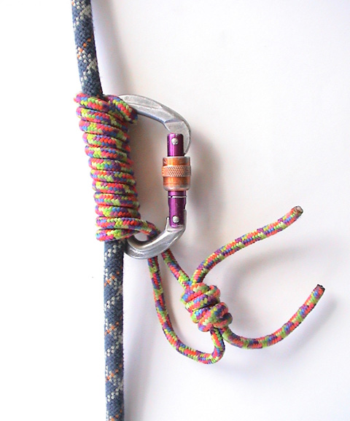
The Bachman Knot
This knot makes use of a carabiner as a handle to ease shifting the knot up and down the rope. Note if you pull down on the carabiner, it will unlock the knot, moving it downwards. Likewise yank the carabiner upwards to shift it in that direction. This knot is not so good on icy ropes. Follow these steps to tie a Bachman knot:
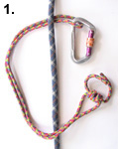
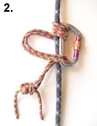

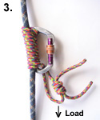
Steps 1 & 2: Clip your loop of cord through a carabiner and begin wrapping the cord around the rope, feeding it through the carabiner with each pass. Keep the wraps nice and snug. Step 3: Allow the tail of the cord to hang down (as pictured), and clip your load to this protruding tail. Do not clip your load to the carabiner functioning as the "handle".
One Method of Racking Your Accessory Cord
Here's one way to rack your prusik cords so that they have a small profile on your harness gear loops. Simply twist the cord about itself. Follow these steps:
When you need to deploy the cord, a quick shake will work out the kinks.
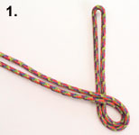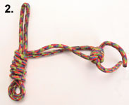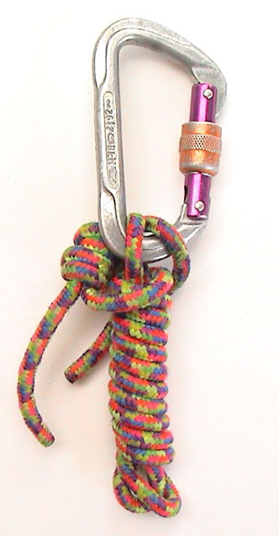
Comparison of knots
Which knot should I use?
The above figure was compiled by Tom Moyer (see http://www.xmission.com/~tmoyer/testing ) around 2000. The Blue Water Titan has a braided Spectra/Nylon core and a Nylon sheath, the Black Diamond Gemini2 has a Technora core and a polyester sheath (same as Maxim’s “Tech Cord”), and Ultratape is a Spectra/Nylon webbing that tries to keep the nylon on the surface. The Spectra A has a braided Spectra/Kevlar core and polyester sheath, and is not as popular anymore.

A dedicated prusik cord is most likely 6mm nylon. The figure above suggests that the prusik and Bachman are strongest in nylon. Indeed, the prusik knot seems to be almost universally the strongest. The advantage of the Bachman is easier sliding. In icy conditions, a prusik might be the best bet.
Not all Spectra has a nylon sheath like the Titan Spectra, so don’t expect your Spectra cord to perform as well as the above figure. Conventional wisdom is: don’t use anything other than nylon for a friction knot. Note: “perlon” is a synonym for nylon cord.

