Butterfly (aka Alpine Butterfly) Knot
There are several methods to tie this; many people prefer to use the “hand” method.
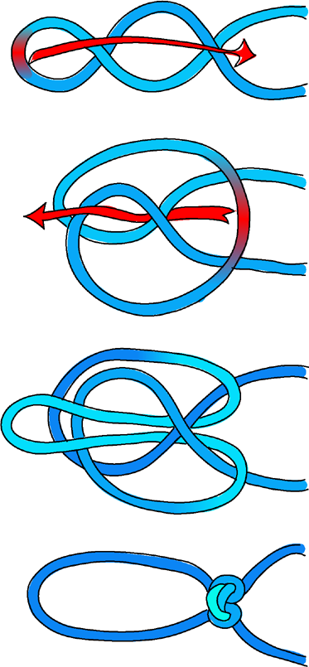
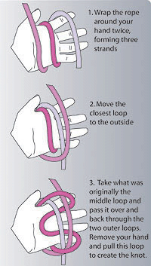
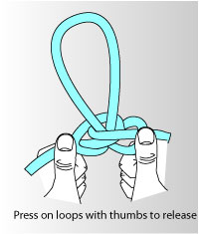
Munter Hitch (aka Italian Hitch)
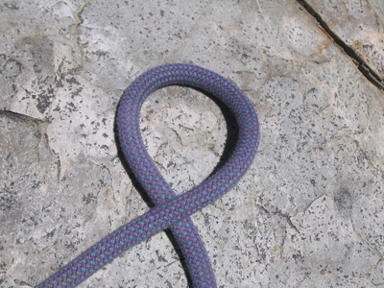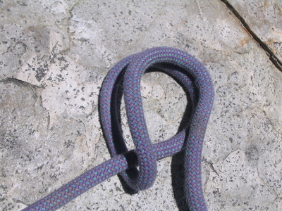
Munter Hitch
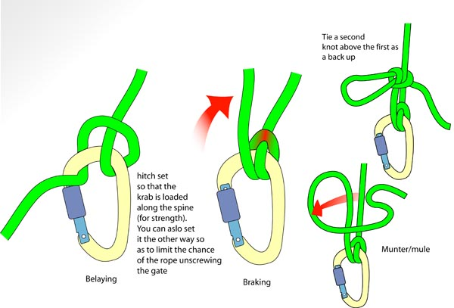
Munter Hitch
The Munter/mule is a way of tying off the Munter hitch. If belaying with a munter, you lock off by bringing the brake strand UP, not DOWN as with a normal belay device. A munter twists the rope, so a belay device is usually the first choice.
Double Fisherman’s (a Triple Fisherman’s is the same, but with an additional loop), aka Grapevine
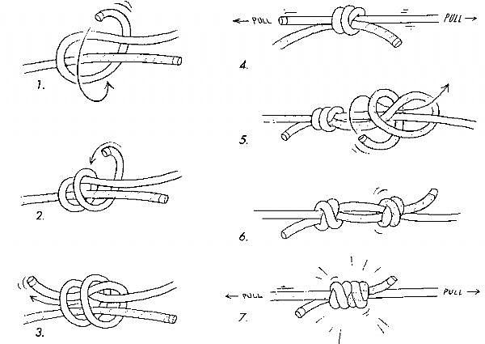

Clove Hitch
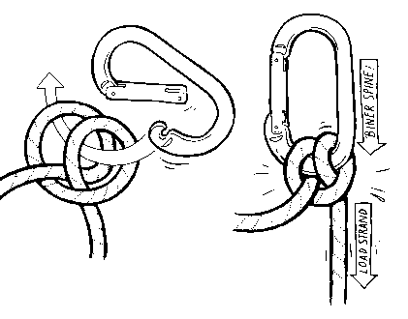
Water Knot [left], Figure-8 follow-through (aka Figure-8 Rewoven) [right]
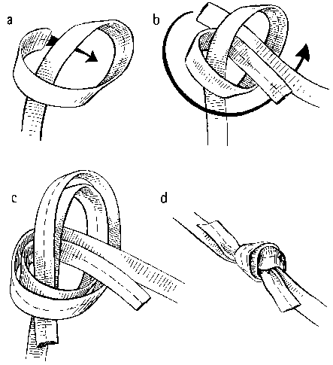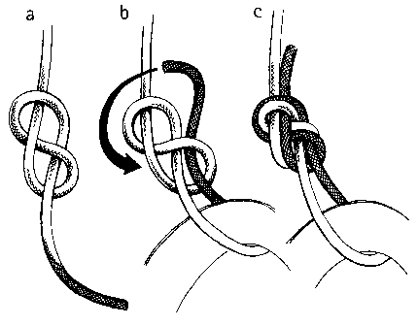
Which knot to use?
Butterfly: this can take loads on both strands, so is used for clipping into the middle of a rope.
Figure-8: the gold-standard for tying in to the end of a rope.
Water knot: for typing a loop of webbing. Do not use this with cord.
Munter: if you don’t have another way to belay, use this
Clove hitch: very fast to tie, and you can adjust it, which makes it extremely useful at belay stations. One important caveat: while this knot is symmetric, carabiners are not. Make sure the load strand is closest to the spine of the carabiner; failure to do so is likely to reduce the carabiner’s strength by roughly 30%.
Double Fisherman’s: for tying cord together, or for tying ropes together
Overhand (not shown here): for tying two ropes together. You can tie ropes together with a variation of the figure-8 follow through, but you cannot use the figure-8 the same way you use an overhand, because it is much more likely to invert. The overhand knot, if tied tightly, is not very likely to invert. This knot is also known as the Euro-Death Knot (“EDK”).

